|  |
| --- |
| Warning!  Paintball and Combat Archery are potentially dangerous activities.  Any participant must read the WAIVER form  BEFORE signing and agreeing to the terms and conditions of the waiver. |

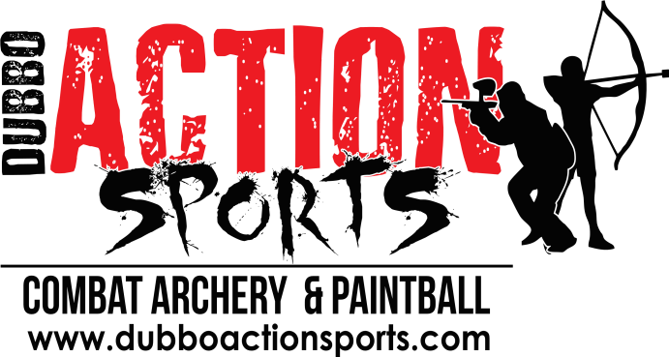

In consideration of participating in the sport of Combat Archery and Paintball, I represent that I understand the nature of this activity and that I am qualified, in good health, and in proper physical condition to participate in such activity. I acknowledge that if I believe event conditions are unsafe, I will immediately discontinue participation in the activity.

I fully understand that this activity involves risk of serious bodily injury which may be caused by my own actions, or inactions, those of others participating in the event, the conditions in which the event takes place, or the negligence of the "releases" named below; and that there may be other risks either not known to me or not readily foreseeable at this time: and I fully accept and assume all such risks and all responsibility for losses, costs, and damages I incur as a result of my own participation in the activity.

I hereby release, discharge, and covenant not to sue Dubbo Action Sports, (Players Paintball Dubbo) its respective administrators, directors, agents, officers, volunteers, and employees, other participants, any sponsors, advertisers, and if applicable, owners and leasers of premises on which the activity takes place, (each considered one of the "RELEASES" herein) from all liability, claims, demands, losses, or damages on my account caused or alleged to be caused in whole or in part by the negligence of the "releases" or otherwise, included negligent rescue operations; and I further agree that if, despite this release, waiver of liability, and assumption of risk I, or anyone on my behalf, makes a claim against any of the RELEASES, I will indemnify, save, and hold harmless each of the RELEASES from any loss, liability, damage, or cost which any may incur as the result of such claim.

**Parent Consent**

I, the minor's parent and/or legal guardian, understand the nature of the above referenced activities and the minor's experience and capabilities and believe the minor to be qualified to participate in such activity. I hereby release, discharge, covenant not to sue and AGREE TO INDEMNITY AND SAVE AND HOLD HARMLESS each of the RELEASES from all liability, claims, demands, losses, or damages on the minor's account caused or alleged to have been caused in whole or in part by the negligence of the RELEASES or otherwise, including negligent rescue operations, and further agree that if, despite this release, I, the minor, or anyone on the minor's behalf makes a claim against any of the above RELEASES, I WILL INDEMNITY, SAVE AND HOLD HARMLESS each of the RELEASES from any litigation expenses, attorney fees, loss liability, damage, or cost any RELEASES may incur as the result of any such claim.

**ACKNOWLEDGMENT AND UNDERSTANDING. ONLY PROCEED AFTER READING THE WAIVER FORM**

I confirm that I have read and understood this Release Agreement prior to signing it, including the description of the inherent risks associated with Archery Tag. I am aware that by signing this Release Agreement I am waiving certain legal rights which I or my heirs, next of kin, executors, administrators, assigns and representatives may have against the Releases. I am also aware that this Release Agreement is intended to be broad and all inclusive, so as to preclude any claims and that I have the legal capacity to sign, or if I am a minor, have discussed fully with my parent or guardian.

My child ______________________________________________ Year ________

(Students full name)

**Parent / Caregiver** signature: __________________________ Date: _______________